7 AUSTIN AVENUE CONDOMINIUM

PURCHASE AND SALE AGREEMENT

1. Parties' Agreement. This Agreement is made among John Voight, of Hanover, Grafton County, New Hampshire, whose mailing address is 7 Austin Avenue Unit 2 (hereinafter collectively referred to as "Seller"), and , of , County of Grafton, State of New Hampshire, whose mailing address is (“Buyer”) and Trustees of Dartmouth College, whose mailing address is c/o Dartmouth College Real Estate Office, P.O. Box 5188, Hanover, NH 03755-5188 (“Dartmouth”), agrees to BUY, upon the terms hereinafter set forth, the premises herein described.

Recitals:

1. Seller is the owner of premises known as Unit 2 of 7 Austin Avenue Condominium (the “Premises’).
2. Seller desires to sell the Premises to Buyer and Buyer desires to purchase the Premises from Seller, on the terms and conditions set forth herein.
3. Dartmouth holds a repurchase right with respect to the Premises pursuant to the Repurchase Option dated October 27, 2014 (“Seller’s Repurchase Option”) and recorded in the Grafton County Registry of Deeds at Book 4091, Page 0916.
4. An Option Event has occurred, giving Dartmouth the right to exercise its repurchase rights under Seller’s Repurchase Option, and Dartmouth has exercised or intends to exercise that right.
5. Seller and Buyer desire Dartmouth to assign it repurchase rights under Seller’s Repurchase Option, and Dartmouth is willing to make such an assignment, provided Buyer will grant to Dartmouth a Repurchase Option with respect to the Premises in the form of Exhibit 4 (“Buyer’s Repurchase Option”), and on the other terms and conditions set forth herein.
6. Premises. Unit No.2 (the “Unit”) of 7 Austin Avenue Condominium, (the “Condominium”) created pursuant to Chapter 356-B of the New Hampshire Revised Statutes Annotated (RSA 356-B) (the “Condominium Act”) by Declaration dated September 4, 2009, and recorded in the Grafton County Registry of Deeds at Book 3644, Page 382, together with (a) an undivided 25.0 percentage interest in both the common areas and facilities of the Condominium and the association of unit owners (the “Association”) through which the Condominium is managed and regulated, (b) the exclusive right to use two (2) garage bays and that portion of the paved parking area immediately adjacent thereto and other limited common areas, if any, assigned to the Unit, and

(c) such other rights and easements appurtenant to the Unit as may be set forth in any document governing the operation of the Condominium, including without limitation the Declaration, the By- Laws of the Association, and any Rules and Regulations adopted pursuant thereto (all of which are

hereinafter referred to as the “Condominium Documents” and are attached hereto as Exhibit 1). The above described premises are a portion of the same premises conveyed the Seller by Warranty Deed of Frank E. Austin dated March 5, 1927 and recorded in the Grafton County Registry of Deeds at Book 598, Page 237, and by Warranty Deed of Stephen E. Chase dated May 26, 1921 and recorded with the Grafton County Registry of Deeds at Book 561, Page 237.

1. Deed. The Premises shall be conveyed by a good and sufficient duly executed Condominium Warranty Deed (the "Deed") furnished by Seller and running to Buyer. The Deed shall convey a good, clear and marketable record title to the Premises, such title defined as insurable by a national title insurance company, free from all liens and encumbrances, recorded and unrecorded, except:
2. Applicable laws and regulations of any governmental authority in effect on the date hereof;
3. Such taxes for the then current fiscal tax period as (i) are not due and payable on the date of delivery of the Deed and (ii) accrue after the date of such delivery;
4. Any liens for municipal betterments assessed after the date of the delivery of the Deed;
5. Buyer acknowledges and agrees that it will purchase the Premises in its "as is" condition, without any warranty or representations by Trustees of Dartmouth College, including, without limitation, any hidden defects, suitability for any particular use, or environmental matters, and Buyer further agrees that Trustees of Dartmouth College shall not be liable for the condition of the Premises, including any latent or patent defects in the Premises.
6. The provisions, terms, conditions, restrictions, obligations, covenants and easements of the Condominium Act and the Condominium Documents including without limitation all obligations of the unit owners to pay a proportionate share of the Common Expenses of the Condominium;
7. All restrictions, easements and encumbrances referred to in the Condominium Documents, and in the Condominium Site Plan and Condominium Floor Plans, recorded in the Grafton County Registry of Deeds as Plan No. 13556 and Plan No. 13557, respectively, and attached hereto as Exhibit 2;
8. Any other matters set forth in the proposed Condominium Warranty Deed attached hereto as Exhibit 3; and
9. The provisions of the Repurchase Option, attached hereto as Exhibit 4.

This unit is sold subject to RSA 356-B:41, II which provides that the Declarant shall warrant and guarantee, against structural defects to the unit and common elements for the period of one year from the date each unit is conveyed.

Seller shall be notified by Buyer in writing of any alleged defects in Seller's title at least fifteen (15) days prior to the Time of Closing or any objection to Seller's title shall be deemed to have been waived.

1. Purchase Price. Buyer shall pay the PURCHASE PRICE of $ 279,500, of which:

$ 1,000.00 Has been paid as a deposit this day;

$ 12,975.00 Shall be paid as an additional deposit within five (5) days following Seller’s acceptance of this Agreement.

$265,525.00 (the remainder of the Purchase Price) shall be paid at the Closing in cash or by Buyer’s certified or cashier's/treasurer's check or checks.

$ 279,500.00 Total Payment.

All deposits made hereunder shall be held by Seller as earnest money for the proper performance of this Agreement on the part of Buyer in accordance with the terms of this Agreement and shall be duly accounted for at the Time of Closing.

Of the $279,500.00 total purchase price, Dartmouth shall retain the sum of $3,745.00, representing a recovery of administrative expenses. The remaining net sale proceeds shall be paid over to Seller at the Time of Closing.

1. Closing. Transfer of title and payment of the purchase price (Closing) shall take place on or before June 30, 2024 at the Dartmouth College Real Estate Office at 4 Currier Place, Suite 305, Hanover, NH, or at the offices of the bank providing financing to Buyer or of the Bank’s or Buyer’s attorneys.
2. Expenses and Prorations. Seller shall pay for the cost of preparing the Deed and the cost of preparing and recording any releases of encumbrances. Buyer shall pay for any title examination and opinion which Buyer may require, the cost of recording the Deed, and the cost of preparing and recording the documents necessary in obtaining a mortgage. The state transfer taxes authorized by RSA 78-B shall be shared equally by the Seller and the Buyer. Taxes for the then current fiscal tax period shall be apportioned and the fuel value shall be adjusted as of the Time of Closing. Water and sewer charges and assessments shall likewise be pro-rated as of the Time of Closing.* If the amount of said taxes has not been determined at the Time of Closing, as extended, they shall be apportioned on the basis of the taxes assessed for the preceding year.

* All four units of the 7 Austin Avenue Condominium share a common water line entrance and common meter. Payment of common water charges and sewer charges (which are determined by water usage through the common meter) are the responsibility of the Association. Proportionate water usage and attendant sewer charges attributable to each the four units are determined by four separate sub- meters. Proportionate water and sewer charges are payable to the Association by the owners of each of the four units.

Pursuant to the Condominium By-Laws, at the Time of Closing, Buyer also shall pay to Seller:

1. $ 300.00, equaling one-twelfth of the projected annual budget for the Association (“Monthly Condo Fee”), attached hereto as Exhibit 4, or, in the event the Time of Closing does not fall of the first day of the month, Buyer shall pay to Seller the pro rata share of the Monthly Condo Fee.
2. $ 600.00**,** representing Buyer’s initial contribution to the Association’s Working Capital Fund, which shall be maintained in a segregated account by the Association.
3. Possession. Full possession of the Premises free and clear of all tenants and occupants, and free of all personal property, shall be delivered at the Time of Closing, the Premises to be then
4. in the same condition as of the date hereof, reasonable wear and tear excepted, (ii) not in violation of any applicable zoning law or regulation of any governmental authority as set forth in Paragraph 3.A., and (iii) not subject to any encroachments by others or requiring encroachments over land of others.
5. Inspection Contingency. Buyer shall have the right, within fourteen (14) days of the execution of this Agreement by both parties, at reasonable times and upon reasonable written, e- mail, or telephonic notice, to have the premises inspected by contractors, tradesmen, engineers, architects, and inspectors of Buyer’s choice, and to perform or cause to be performed whatever tests are appropriate to determine that the Unit and the Common Areas, including but not limited to roof, foundation, walls, floors, ceilings, and heating, cooling, plumbing, water, sewer, and electrical systems, are structurally sound and in good condition, repair, and working order, and that they are not contaminated by radon in the air or water, by asbestos, or by other contaminant or hazardous substance. If the results of any such inspections are not reasonably satisfactory to Buyer, then Buyer shall have the right to give written notice to Seller within such fourteen (14) day period that it is terminating this Agreement, following which the deposit promptly shall be refunded to Buyer and this Agreement thereupon shall be terminated and of no further force and effect.
6. Financing Contingency: Buyer's obligation hereunder to purchase shall be contingent upon the Buyer's receipt of mortgage financing approval at a local bank for a first mortgage for an amount not more than $_________, with interest at the current prevailing rates, for which the Buyer shall forthwith proceed to make a mortgage application within five (5) days of the signing of this Agreement and with due diligence to prosecute such application. If Buyer shall not have secured such mortgage financing approval/commitment on or before 4:00 P.M. on , 2018, Buyer may give written notice to the Seller or Seller's agent by such date, upon receipt of which, this Agreement shall thereupon become null and void. If the Seller or Seller's agent receives no such notification by such date, then this condition shall lapse and have no effect, and the Buyer shall be obligated to perform this Agreement according to all other terms and conditions.
7. Insurance. At the time of delivery of the deed, Seller shall deliver to Buyer a certificate of the Condominium insurance as then in effect. Any supplemental insurance shall be at the option and sole expense of Buyer, but Buyer is encouraged to arrange for such insurance.
8. Buyer's Default. If Buyer shall fail to fulfill its obligations hereunder, any deposits made hereunder by Buyer may at Seller's option be retained by Seller as its full and liquidated

damages or Seller may pursue any and all other rights and remedies which Seller may have against Buyer at law or in equity for such failure. Such amount constitutes liquidated damages and not a penalty and is the parties' best estimate as of the date hereof of the damages which would accrue to Seller in the event of a default by Buyer hereunder.

1. Seller's Default. If Seller shall be unable to give title as herein stipulated, then Seller shall use reasonable efforts to remove all encumbrances which secure the payment of money including, but not limited to, attachments, liens and mortgages, and use reasonable efforts to remove all other defects in title, and the Time of Closing shall be extended for a period of not to exceed thirty (30) days.

If at the expiration of the extended time Seller shall have failed to remove any defects in title or to deliver possession, as the case may be, all as herein agreed, then any payment made under this Agreement shall be refunded forthwith and all other obligations of all parties hereto shall cease and this Agreement shall be void and without recourse to the parties hereto.

1. Acceptance of Deed. The acceptance of the Deed by Buyer shall be deemed to be a full performance and discharge of every agreement and obligation of Seller herein contained or expressed.
2. Broker. Buyer and Seller mutually represent and warrant that they have dealt with no broker or agent in connection with this transaction, and each party covenants and agrees to defend, indemnify and hold harmless the other party (including reasonable attorneys' fees) from and against any and all claims for brokerage commission arising out of this transaction by any broker who establishes by court action a right to such a commission arising out of his dealings with the indemnifying party. Both parties shall have the right to participate in the defense of any such action.
3. Notices. All notices required or permitted to be given hereunder shall be in writing and delivered by hand or mailed postage prepaid, by registered or certified mail, at the address set forth in Paragraph 1, or in the case of either party to such other address as shall be designated by written notice to the other party.
4. Statutory Notices.
5. In compliance with the requirements of RSA 477:4-a, Seller hereby provides the following notification to the Buyer with respect to Radon Gas and Lead Paint:

RADON GAS: Radon gas, the product of decay of radioactive materials in rock, may be found in some areas of New Hampshire. This gas may pass into a structure through the ground or through water from a deep well. Testing can establish its presence and equipment is available to remove it from the air or water.

LEAD PAINT: Before 1977, paint containing lead may have been used in structures. The presence of flaking lead paint can present a serious health hazard, especially to young children and pregnant women. Tests are available to determine whether lead is present.

Buyer acknowledges receipt of pamphlet entitled “Protect Your Family From Lead in Your Home.”

1. In compliance with the requirements of RSA 477:4-c, Seller also hereby discloses the following information to Buyer with respect to Water Supply and Sewage Disposal:

WATER SUPPLY SYSTEM: The water supply system which serves the building is a public system operated by the Hanover Water Works Company.

SEWAGE DISPOSAL SYSTEM: The sewage disposal system which serves the building is a public system, operated by the Town of Hanover.

1. CONDOMINIUM DOCUMENTS: In compliance with the Condominium Act, Seller also is hereby providing to Buyer, and Buyer hereby acknowledges receipt of, copies of the Condominium Documents, Condominium Site Plan, and Condominium Floor Plans attached hereto as Exhibit 1 and Exhibit 2.

This instrument, executed this day of , 2024, is to be construed as a New Hampshire contract, sets forth the entire contract between the parties, is binding upon and inures to the benefit of their respective heirs, devisees, executors, administrators, successors and assigns, and may be cancelled, modified or amended only by a written instrument executed by both Seller and Buyer.

Seller:

By:

Witness

Buyer:

Witness

Buyer:

Witness

Agreement

Dartmouth agrees to the foregoing offer and agrees to assign its right to purchase the Premises under Seller’s Repurchase Option on the terms and conditions set forth herein. Dartmouth acknowledges receipt of a copy hereof.

Date:

TRUSTEES OF DARTMOUTH COLLEGE

Signature:

By:_

Its Duly Authorized:

# EXHIBIT 1

Declaration of Condominium- 7 Austin Avenue

# EXHIBIT 2

7 Austin Avenue Condominium Site and Floor Plans

# Identification and Assignment of Limited Common Areas (LCA’s)

Unit 1:

LCA’s Appurtenant to Unit 1:

Garage bays Nos. 1 and 2 shown on Site Plan

Paved area in front of garage bays Nos. 1 and 2 shown on Site Plan Exterior stairs to Unit 1 entrance on south side of building

Exterior stairs and patio adjacent to Unit 1 on east side of building

Common Area in Basement of Unit 1 - Unit 1 is subject to the common area rights of the Association and the owners of Units 2, 3 and 4 to access the utility service panel along the westerly foundation wall via the basement bulkhead and stairs on west side of building to basement of Units 1 and 2, and via the basement vestibule providing access to Unit 1 and Unit 2 basements

Unit 2:

LCA’s Appurtenant to Unit 2:

Garage bays Nos. 3 and 4 shown on Site Plan

Paved area in front of garage bays Nos. 3 and 4 shown on Site Plan South half of porch adjacent to Unit 2 on west side of building Porch of east side of building (in common with Unit 3)

First floor vestibule (in common with Unit 3)

Bulkhead and stairs on west side of building to basement of Units 1 and 2 Basement vestibule providing access to Unit 1 and Unit 2 basements

Access easement in Basement of Unit 2 - Unit 2 is subject to the rights of the Association and the owners of Units 1, 3 and 4 to access the main water entrance and meter in the Unit 2 basement

Unit 3:

LCA’s Appurtenant to Unit 3:

Garage bays Nos. 5 and 6 shown on Site Plan

Paved area in front of garage bays Nos. 5 and 6 shown on Site Plan North half of porch adjacent to Unit 3 on west side of building Porch on east side of building (in common with Unit 2)

First floor vestibule (in common with Unit 2)

Bulkhead and stairs on west side of building to basement of Units 3 and 4 Basement vestibule providing access to Unit 3 and Unit 4 basements

Unit 4:

LCA’s Appurtenant to Unit 4:

Garage bays Nos. 7 and 8 shown on Site Plan

Paved area in front of garage bays Nos. 7 and 8 shown on Site Plan Exterior stairs to Unit 4 entrance on north side of building

Exterior stairs and patio adjacent to Unit 4 on east side of building Bulkhead and stairs on west side of building to basement of Units 3 and 4 Basement vestibule providing access to Unit 3 and Unit 4 basements

# Site Plan No. 13556

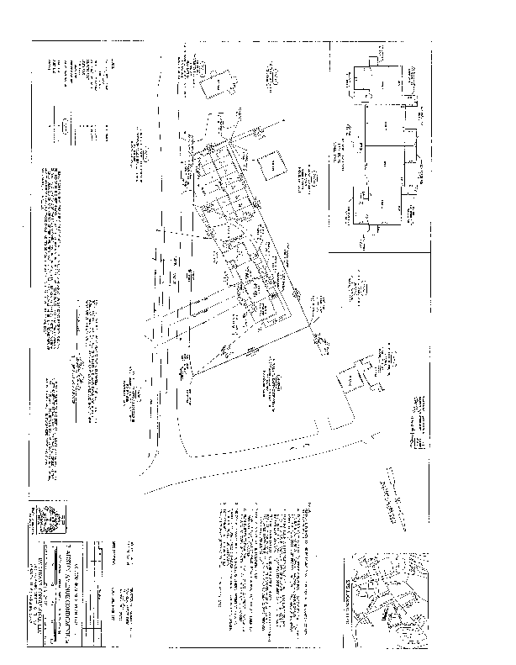

**Floor Plan No. 13557**

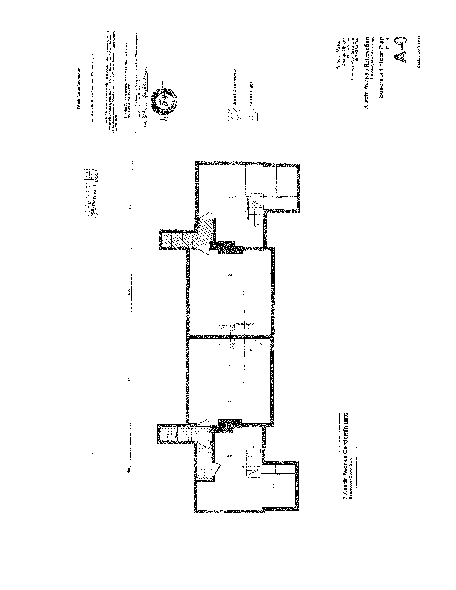

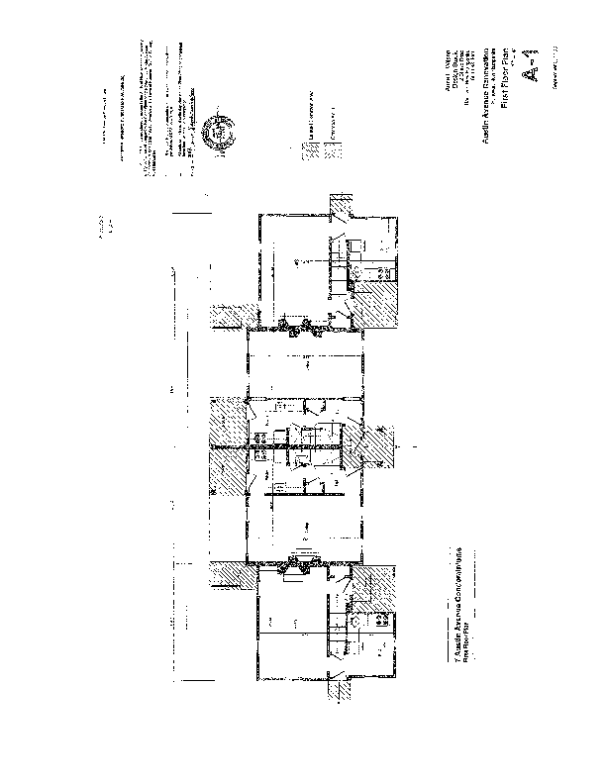

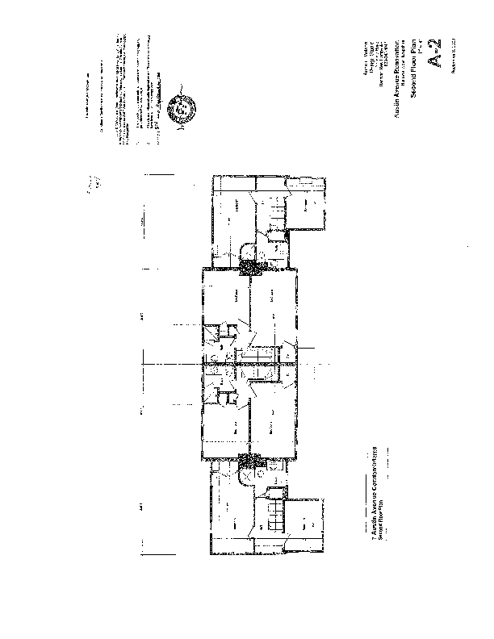

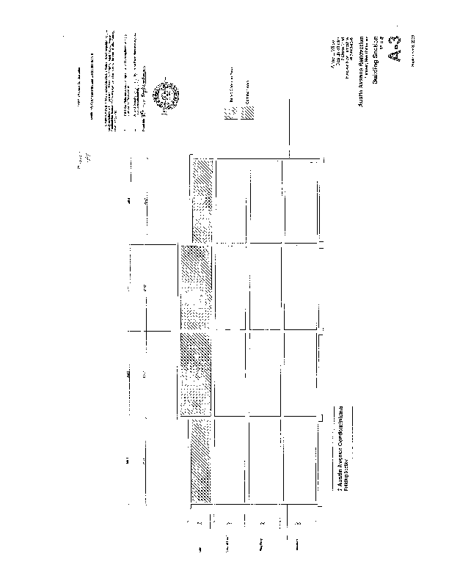

**EXHIBIT 3**

Warranty Deed

# Exhibit 4

Repurchase Option

I, , of Hanover, County of Grafton and State of New Hampshire, whose mailing address is , Hanover, NH 03755 ("Grantor") grant this Repurchase Option to Trustees of Dartmouth College, a corporation created by Royal Charter and existing under the Laws of the State of New Hampshire, with a principal place of business in Hanover, Grafton County, New Hampshire, and a mailing address of c/o the Dartmouth College Real Estate Office, P.O. Box 5188, Hanover, NH 03755 ("Dartmouth"), regarding Condominium Unit 4 located in the 7 Austin Avenue Condominium, at 7 Austin Avenue, Hanover, NH 03755 (the "Premises"), and for other good and valuable consideration.

1. Option Events. Dartmouth shall have the option to repurchase the Premises upon the occurrence of any one of the following events ("Option Events"):
   1. The giving of notice to Dartmouth of Grantor's (i) intent to sell or (ii) contract to sell the Premises.
   2. The first anniversary of the death of the Grantor. In the event that more than one person is named above as Grantor, "Grantor" for purposes of this paragraph shall mean the survivor of them.
   3. During the life of the Grantor, upon the sale or transfer of the Premises, including the conveyance of the premises or any right, title or interest therein, whether legal or equitable, whether voluntary or involuntary, with or without consideration, by outright sale, deed, installment sale, contract, land contract, contract for deed, lease with a term greater than one (1) year (except for a lease meeting the requirements set forth in d. below), lease option contract, or of any easements (other than standard utility easements), covenants, restrictions, conditions, or limitations affecting the premises, or any other method of conveyance of real property interest. Not included within the definition of sale or transfer shall be:
      1. Any taking of any portion of the premises by eminent domain or related proceedings, such as for highway improvements or other public purposes,
      2. In the event that more than one person is named above as Grantor, the transfer of an undivided fractional interest in the premises by one Grantor to the other, but the Grantors shall provide Dartmouth's Real Estate Office with a copy of the recorded deed by which such interest was conveyed,
      3. Any transfer to one or more lineal descendants,
      4. The giving of a mortgage to a Bank or other financial institution,
      5. The sale of the premises at foreclosure by such Bank or other financial institution, or the sale of the Premises at foreclosure by such Bank or other financial institution,
      6. The giving of a deed in lieu of foreclosure to such Bank or other financial institution. In the event of a sale of the premises at foreclosure or the Grantor's giving of a deed in lieu of foreclosure, Dartmouth's option to purchase the premises shall expire and be of no further force or effect.
   4. The first anniversary of the date on which the Premises shall cease to be used by the Grantor as his or her principal residence. A lease of the Premises, however, for two (2) years or less while a Grantor is on an approved leave from Dartmouth shall not constitute, by itself, such cessation of use. In addition, in the event that two persons are named above as Grantor, the Option shall not be exercisable if one Grantor ceases so to use the Premises, provided that (i) the other continues so to use the Premises, even if the other is not an employee of Dartmouth, and either (ii-a) the other has become the owner of the Premises or entitled to occupy the Premises pursuant to a Court Order in a divorce or other domestic relations proceeding and has provided a copy of the Court Order to Dartmouth's Real Estate Office or (ii-b) the Grantor who has ceased to use the Premises has done so as the result of being required to reside in hospital, assisted living residence, nursing home or similar placement outside the home.
   5. The first anniversary of the earlier of (i) the date on which the Grantor's employment by Dartmouth shall cease, other than as a result of (x) retirement from full-time employment or (y) early retirement necessitated by disability, or (ii) the date as of which the Grantor is no longer eligible to receive full "Dartflex" benefits. In the event that more than one (1) person is named above as Grantor, the Option shall not be exercisable if one Grantor leaves the employment of Dartmouth, so long as the other (i) is in the employ of Dartmouth and eligible to receive full "Dartflex" benefits, or (ii) leaves or has left such employment only as a result of retirement from full-time employment or of early retirement necessitated by disability, or (iii) has become the owner of the Premises or entitled to occupy the Premises pursuant to Court Order in a divorce or other domestic relations proceeding and has provided a copy of the Court Order to Dartmouth's Real Estate Office.
   6. At such time as the Grantor shall fail to meet or shall contravene any obligation assumed under this Repurchase Option, or the Deed, including any provision of any Schedule to the Deed, or shall be given notice of default or acceleration by the Mortgagee of the amounts due under any Mortgage encumbering the Premises, or otherwise shall fail to meet or shall contravene any obligation assumed under such Mortgage or the Note secured by it.
2. Notice to Dartmouth.
   1. Informational Notice. Promptly upon the happening of the event which on its first anniversary will become an Option Event, in the case of paragraphs 1.b.(death), d.(cessation of use as principal residence), or e.(termination of employment), the Grantor shall give an Informational Notice to Dartmouth. This notice may be given in person, by telephone, or in writing. Its purpose is not to trigger the time period within which Dartmouth must exercise its Option, but is simply to make Dartmouth aware that the property in question will become subject to the exercise of Dartmouth's Repurchase Option.
   2. Formal Option Notice. In addition to any required Informational Notice, the Grantor shall give Dartmouth formal written notice of the occurrence of any Option Event ("Formal Option Notice"). Such Formal Option Notice shall be accompanied by substantiation of any Improvements Costs claimed by the Grantor under the provisions of paragraph 5 below, and shall also include, if

applicable, a copy of the contract of sale. If the Option Event is specified in paragraph 1.a., c., or f., the Notice shall be given within ten (10) days of the occurrence of the Event. If the Option Event is specified in paragraph 1.b., d., or e., the Notice shall be given prior to the first anniversary of the Grantor's death, cessation of use as principal residence, or termination of employment, as the case may be. Such Formal Option Notice shall be hand-delivered or mailed by certified mail, return receipt requested, postage pre-paid, to the Dartmouth College Real Estate Office, P.O. Box 5188, Hanover, NH 03755, and shall set forth the return address of the sender. Acknowledgment of receipt of such Formal Option Notice must be in writing, signed by the Director of Real Estate, the Associate Director of Real Estate, or their designated representative. Failure of Grantor to give Formal Option Notice to Dartmouth as set forth above shall stay any time which Dartmouth may have to exercise its repurchase option.

1. Right to Show and Market. Following Dartmouth’s receipt of Grantor's Formal Option Notice, and even if Dartmouth shall not yet have exercised its Option, Dartmouth shall be provided with reasonable access to the Premises in order to show the property to prospective third party purchasers through one or more open houses or individual showings. The parties agree that Dartmouth in general shall have access comparable to the access provided to a broker under a Multiple Listing Service listing agreement and that they shall cooperate and coordinate the details of such access. Grantor in addition shall maintain the Premises in a good and attractive condition in order to assist in the marketing of the Premises; such maintenance shall include without limitation keeping the grass and any shrubs neatly trimmed and the area around the residence neat, tidy, and free of trash. In the event that the Grantor shall not so maintain the Premises, Dartmouth may do so at the Grantor's expense.
2. Exercise by Dartmouth.
   1. Cooperation to Determine Option Price. Promptly following Dartmouth's acknowledgment of receipt of the Formal Option Notice, Dartmouth's Director of Real Estate, Associate Director of Real Estate, or their designated representative shall contact the Grantor, and the parties shall meet and otherwise reasonably cooperate to determine the (i) Capped Amount and
3. the Fair Market Value or Contract Price, as applicable, all as defined in paragraph 5. below. The parties may choose to waive the need for an appraisal to determine Fair Market Value, for example, because they are convinced that the Capped Amount would be lower than Fair Market Value. In connection with determining the Option Price, the Grantor shall allow access to the Premises by Dartmouth's representatives and if an appraisal is required, by the appraiser. The parties shall reasonably cooperate so that both the Capped Amount and if applicable, the Fair Market Value may be determined within forty-five (45) days of Dartmouth's receipt of the Formal Option Notice.
   1. Exercise of Option. If the Option Event is the Grantor's contract to sell the Premises, Dartmouth shall have sixty (60) days following its receipt of a complete copy of the fully-executed contract within which to exercise its Option to repurchase; in all other cases, Dartmouth shall have sixty (60) days after it and the Grantor either (i) shall have agreed upon the identity of the appraiser or(ii) agreed that an appraisal is not required within which to exercise its Option to repurchase. If the Capped Amount and, if applicable, the Fair Market Value, have not been determined within such sixty (60)-day period, Dartmouth shall have fifteen (15) days following such determination within which to exercise its Option to repurchase. If it chooses to exercise that Option, Dartmouth

shall send written notice of such exercise to the Grantor and such notice of exercise shall be deemed given when hand delivered or mailed by Certified Mail, return receipt requested at the return address specified in the Formal Option Notice, or failing such address, at the Grantor's mailing address set forth above. Dartmouth may also exercise its Option in the same manner at any time after an Option Event has occurred and before receiving the Formal Option Notice. Failure by Dartmouth to exercise its option after an option event has occurred and before receiving the Formal Option Notice shall not be deemed a waiver by Dartmouth of its Option.

* 1. Withdrawal of Notice of Intent to Sell. If (i) the Grantor has given notice to Dartmouth of intent to sell, (ii) Dartmouth has exercised its Option, (iii) the Option Price is established by an appraisal of Fair Market Value which is less than the Capped Amount, and (iv) the Grantor believes that the Fair Market Value as determined by appraisal is less than the actual value, the Grantor shall have three (3) days following the Grantor's receipt of Dartmouth's notice of exercise within which to rescind the Grantor's notice of intent to sell, by written notice given in the manner provided in paragraph 2. If the Grantor so elects to rescind, the Grantor shall pay the entire cost of the appraisal. The Grantor thereupon may place the Premises on the market, but the subsequent occurrence of an Option Event, including a contract to sell the Premises, shall be subject to the notice and other provisions of this Repurchase Option and shall entitle Dartmouth to exercise its Option.

1. Option Price. The purchase price to be paid by Dartmouth upon the exercise of its Option ("Option Price") shall be determined as set forth below.
   1. Definitions. The following definitions shall apply:
2. CPI: Defined as the Consumer Price Index for All Urban Consumers - (CPI-u) - Northeast Region - Housing, as published in the CPI Detailed Report by the U.S. Department of Labor Bureau of Labor Statistics. If said CPI index is discontinued or revised during the period of this Agreement, such other governmental index or computation which Dartmouth reasonably determines to most closely approximate said CPI index shall be used. Where reference is made to the CPI as of a date a number of months prior to a date certain, the CPI used shall be the CPI for the month of the date specified (for example, the CPI six (6) months prior to April 25, 2001 shall be the CPI for the month of October, 2000). CPI six (6) months prior to Grantor's Purchase is agreed to be 342.437 .
3. Capped Amount: Defined as the sum of: (i). The greater of:
   1. The original purchase price or
   2. (A X B/C), where:

A = The Original Purchase Price, set forth in subparagraph 6) below;

B= CPI eighteen (18 ) months prior to the earlier of the date on which Dartmouth receives Formal Option Notice or the date by which Dartmouth should have received such Notice; and

C= CPI six (6) months prior to Grantor's purchase, as set forth in subparagraph 1. above, plus

(ii). Improvement Costs, as limited by (5) below.

1. Contract Price: Defined as the net consideration (after deducting commissions payable to a real estate agent if an agent is involved in the sale) that was or would be realizable by the Grantor from a sale pursuant to a valid enforceable contract of sale between the Grantor and a bona fide third-party purchaser.
2. Fair Market Value: Defined as the value of the Premises as of the date that Formal Option Notice is received by the College Real Estate Office, as determined by a New Hampshire licensed residential or certified general real estate appraiser (or if licensing is not then required by the State of New Hampshire, an appraiser at least ten (10) of whose appraisals have been accepted for first mortgage purposes by state or nationally-chartered banks in the Hanover, New Hampshire area within the past year), such appraiser to be reasonably agreed upon by Dartmouth and the Grantor. In the event of a sale or transfer of the premises for no consideration, or the death of the Grantor, the Fair Market Value of the premises shall be as of the date of such transfer for no consideration or of the Grantor's death, as the case may be. The appraiser shall be instructed to make adjustments to any sales of other Units in the Condominium used as comparables, if such sales by Dartmouth occurred as part of an affordable housing program and are subject to this or other repurchase option with a restricted buyback price.
3. Improvements Costs: Defined as those costs not included in the Original Purchase Price but which would be recognized under the Internal Revenue Code for the purpose of increasing the homeowner's basis for tax purposes. Up to Two Thousand Five Hundred Dollars ($2,500) for each year of ownership (prorated for partial years) may be included in the Capped Amount, but not to exceed a maximum of Twenty Five Thousand Dollars ($25,000).

In the event that the Grantor desires to have any Improvements Costs included in the Capped Amount, the Grantor must provide to Dartmouth, at the time Formal Option Notice is given or at the time by which such Notice was required to have been given, whichever is earlier, receipts substantiating all Improvements Costs. Improvements Costs which are not so substantiated at that time shall not be included in the calculation of the Capped Amount.

1. Original Purchase Price: Defined as the gross Dollar amount Grantor paid for the Premises, agreed to be $215,740.
2. Determination of Price. The Option Price shall be the amount determined as set forth below, less a five percent (5%) transaction charge to cover Dartmouth's overhead and costs in connection with the repurchase:
   1. If the Option Event is the giving of notice under paragraph 1.a. (ii), the Option Price shall be the lesser of the Capped Amount or the Contract Price.
   2. In the case of any other Option Event, the Option Price shall be the lesser of the Capped Amount or the Fair Market Value.
3. Price Adjustment. In the event that Dartmouth, after its receipt of the Formal Option Notice, shall determine that renovations or improvements to the Premises are required in order to enhance marketability, the Grantor shall reasonably cooperate with Dartmouth to effect such renovations or improvements at Dartmouth's cost. Should Dartmouth assign its purchase

rights under this Option to a third person, so that such person ("Buyer") purchases the Premises directly from the Grantor, Dartmouth's direct and indirect costs to effect such renovations and improvements shall be added to the Option Price (but the amount of such costs shall not be subject to the five percent [5%] transaction charge provided for under par. b. above) and the Option Price as increased by such renovation/improvement costs shall constitute the purchase and sales price as between the Grantor and the Buyer, but the Grantor shall reimburse such costs to Dartmouth out of the sales proceeds. Should Dartmouth itself purchase the Premises directly from the Grantor, such costs shall not be added to the Option Price or otherwise be reimbursable by the Grantor to Dartmouth.

1. Closing. Closing of title and delivery of possession of the property ("Closing") shall occur on the 180th day following the date on which Dartmouth shall have given written notice of exercise of its Option (or on the next business day, if such date falls on a weekend or legal holiday), provided, however, that Dartmouth shall have the right, at any time after exercise of its Option, to give a further written notice specifying an earlier closing date which shall be not less than thirty
2. days after the date of such further notice. Unless otherwise agreed by the parties, the Closing shall be held at 9:00 a.m. at the offices of Dartmouth's Real Estate Office, 7 Lebanon Street, Hanover, NH. Risk of loss or damage to the premises during the period between the exercise of the Option and the Closing shall be on the Grantor. All parties shall attend a pre-closing walk-through inspection of the house at 8:00 a.m. immediately prior to the closing.
   1. Title. The Grantor shall be obligated to convey good and marketable title to Dartmouth, subject only to those liens, encumbrances, easements, and other matters set forth in the Deed and in this Repurchase Option, which obligation shall include, without limitation, the obligation, at the sole expense of the Grantor, to expend whatever moneys are necessary to render title to the premises marketable.
   2. Possession. The Grantor shall be obligated to ensure that the Grantor and any tenants or other persons having possession shall have vacated the Premises, and that all personal belongings and personal property (other than fixtures, all of which shall be included in the sale) shall have been removed from the Premises, by 11:59 p.m. of the day preceding the closing.
   3. Documents and Costs. The Grantor at its expense shall prepare and deliver to Dartmouth the Warranty Deed and Declaration of Consideration, and each party shall execute any title insurance affidavits, closing statements, tax forms, disclosures, and other documents and instruments legally required or customarily delivered at or in connection with a real estate closing. The Grantor in addition promptly following its Formal Option Notice to Dartmouth shall complete and deliver to Dartmouth at its request a form of "seller's disclosure" providing information relating to the condition of the Premises and such other information as is routinely provided to a broker at the time a property is listed for sale. Each party shall pay, at the Closing, one-half (1/2) of the appropriate New Hampshire realty transfer tax and one-half (1/2) of the cost of appraiser's fees, if an appraisal was required to determine the Fair Market Value, and real property taxes, other assessments, and utilities expenses shall be apportioned as of the date of Closing.
3. Condition of the Premises at Closing: The Premises shall be delivered to Dartmouth at the Closing in the same condition as they were in as of the date of Dartmouth's inspection, excepting any repairs performed by Grantor in accordance with paragraph 5.c. If any deterioration in excess of $200.00 is reasonably deemed by Dartmouth or its duly authorized agents to have occurred between the date of its inspection and the Closing, an amount estimated by Dartmouth to remedy

the deterioration may, at Dartmouth's option, be held in escrow by Dartmouth to effectuate the necessary repairs. Any amounts left over after the necessary repairs have been made shall be returned to the Grantor.

1. Non-Exercise by Dartmouth.
   1. In General. In the case of an Option Event other than notice of intent to sell under paragraph 1.a.(i) or termination of employment under paragraph 1.e., unless Dartmouth shall have given written notice of exercise of its Option before the expiration of the period after receipt of Formal Option Notice set forth in paragraph 4.b. above, its Option to repurchase shall be deemed permanently waived. If Grantor desires Dartmouth to execute a consent to sale/release of option in order to evidence such waiver, Grantor shall provide the desired consent/release, in form and content reasonably satisfactory to Dartmouth.
   2. Notice of Intent to Sell. If the Option Event is notice of intent to sell under paragraph 1.a.(i), and if Dartmouth shall not exercise its Option as provided in paragraph 4.b., the subsequent occurrence of any other Option Event, including a contract to sell the Premises, shall require notice to Dartmouth and shall entitle Dartmouth to exercise its Option, all as set forth in paragraph 4.b., but Dartmouth shall have thirty (30) days, not sixty (60) days, following its acknowledgment of receipt of Formal Option Notice within which to exercise its Option. In such event, if Dartmouth shall not have given written notice of exercise of its Option before the end of such thirty (30) day period, as it may have been extended under paragraph 4.b. in the event that the Capped Amount and the Fair Market Value shall not have been determined within such period, its Option to repurchase shall be deemed permanently waived.
   3. Termination of Employment. If the Option Event is termination of Grantor's employment by Dartmouth under paragraph 1.e., and if Dartmouth shall not exercise its Option as provided in paragraph 4.b., the subsequent occurrence of any other Option Event, including a contract to sell the Premises, shall require notice to Dartmouth and shall entitle Dartmouth to exercise its Option, and Dartmouth shall have the time period set forth in par. 4.b. within which to exercise its Option. In such event, if Dartmouth shall not have given written notice of exercise of its Option within the time period set forth in that paragraph, its Option to repurchase shall be deemed permanently waived.

In addition, in the case of termination of employment, but subject to the provisions just set forth in the event of an intervening Option Event, Dartmouth shall have the following additional, periodically recurring option:

On every third anniversary of the April 15th first occurring after Dartmouth's acknowledgment of receipt of the Formal Option Notice, Dartmouth shall be deemed to have received a new written Formal Option Notice of the occurrence of a paragraph 1.e. Option Event and Dartmouth thereupon shall have the right to exercise its Option to repurchase as provided in paragraph 4. [By way of illustration, if the Grantor leaves Dartmouth's employment on June 1, 2004, and gives Formal Option Notice to Dartmouth on June 1, 2004, Dartmouth at that time would have the right to exercise its Repurchase Option. Should Dartmouth not exercise its Option at that time, Dartmouth would be deemed to have received a new notice on April 15, 2008, and every three

(3) years thereafter, and on each such occasion again would have the right to exercise its Repurchase Option.]

1. Authority to Bind. In the event that more than one person is named above as Grantor and unless either or both shall have given written notice to Dartmouth to the contrary, either Grantor shall have the authority on behalf of the other to give and receive notices and otherwise act on behalf of the other in all respects under this Repurchase Option, and Dartmouth shall have no liability for relying on such authority.
2. Miscellaneous. The provisions herein are binding on the heirs, devisees, successors, assigns, transferees, executors, administrators and personal representatives of the Grantor and shall inure to the benefit of Dartmouth, its successors and assigns. Dartmouth shall have the right to assign its rights hereunder at any time, in whole or in part, and shall provide to Grantor prompt written notice of any assignment.

The Grantor releases all rights of dower or curtesy, homestead or other exemption from attachment and levy or sale on execution, and all other rights in and to the Premises.

WITNESS our hand(s) this day of , 2015.

Witness Buyer

STATE OF NEW HAMPSHIRE GRAFTON COUNTY, SS.

On this the day of , 2015 personally appeared the above-named

, known to me (or satisfactorily proven) to be the person whose name is subscribed to the within instrument, and acknowledged that he executed the same for the purposes therein contained. Before me,

Notary Public/Justice of the Peace/

Commissioner of Deeds

My Commission expires: (SEAL)